**DAY 2 ASSIGNMENT – 4**

**Test-Driven Development (TDD) – Infographic**

Test-Driven Development (TDD) is a software development methodology that emphasizes writing tests before writing the actual code**.**TDD follows a cyclical pattern, often referred to as the “Red-Green-Refactor” cycle, which consists of the following steps:

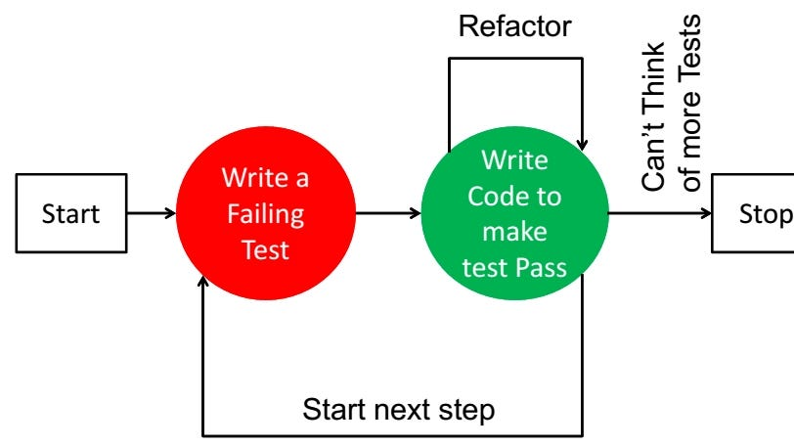

**Step 1: Write a Failing Test**

**Before writing the actual method, the developer writes a unit test that expects a specific behaviour.  
Example: “If the input is 4, the method should return true.”**

**Since the method does not exist yet, the test will fail.**

**Step 2: Write Minimum Code to Pass the Test**

**Now, the developer writes just enough code to make the test pass.**

**In this case, they create a method that checks whether the number is divisible by 2.**

**Once this is done, the test passes.**

**Step 3: Refactor**

**After passing the test, the developer cleans up the code:**

* **Improves naming**
* **Removes repetition**
* **Organizes logic**

**They make sure that all the tests still pass after refactoring.**

**Step 4: Repeat for More Features**

**Now the developer can add more test cases:**

* **Test for odd numbers**
* **Test for zero**
* **Test for negative numbers**

**Each time, they follow the same Red → Green → Refactor cycle.**